  Twin Tec | Installation Instructions for Ignition Model 1005-IH Version for American IronHorse® Motorcycles

CAUTION: CAREFULLY READ INSTRUCTIONS BEFORE PROCEEDING. Not legal for sale or use in California or on any pollution controlled vehicles.

OVERVIEW
American IronHorse® motorcycles manufactured through 2003 used a non-adjustable camshaft sensor based ignition system manufactured in England by Gill. Twin Tec now offers the Model 1005-IH version of our proven internal ignition that can be easily retrofit to 2003 and earlier American IronHorse® models. The Model 1005-IH has a special tach output that will correctly drive the American IronHorse instrument cluster. Note: for 2004-2006 American IronHorse® models with crankshaft position sensor, we recommend our TC88A-IH system.
The Model 1005-IH offers adjustable advance, adjustable RPM limit settings in 100 RPM increments, and switch selectable single or dual fire modes. Single fire mode is used for the American IronHorse® application and improves starting, reduces the occurrence of backfiring at low RPM, and improves power at high RPM. A red status LED flashes when the engine reaches top dead center (TDC) and allows easy static timing. The status LED also provides diagnostic information. A green VOES LED illuminates when the VOES (vacuum switch) input is active.
A special feature allows use of the tachometer wire for a PC link to a laptop computer when the engine is not running. Individual units can be programmed with a custom advance curve and other engine parameters such as rear cylinder timing offset. The use of the tachometer wire for the PC link eliminates the need to remove the outer cover plate.

AVOIDING HEAT RELATED FAILURES
Heat kills electronics. The Model 1005 uses electronic devices rated for operation at 105 deg C (221 deg F), the highest rating available. The unit can tolerate somewhat higher temperatures, but exposure to temperatures above 125 deg C (257 deg F) will greatly reduce life expectancy. We sometimes see problematic applications where several module failures have occurred. The failure mode is a classic thermal intermittent where the module stops firing one cylinder when it gets hot. We have found that these problematic applications share one or more of the following characteristics:
- VOES switch removed or non-functional. All street driven engines require vacuum advance. Without vacuum advance at idle and part throttle, thermodynamic efficiency is reduced and engine temperatures increase significantly.
- Improper carburetor jetting resulting in lean air/fuel ratio (AFR). A lean AFR will cause the engine to run very hot. All performance engine modifications necessitate carburetor rejetting. Carburetors are never correctly jetted out-of-the-box. The only practical means of correctly jetting a carburetor is to test the motorcycle on a chassis dyno equipped with an exhaust gas sniffer or to use our WEGO system.
- Lack of an oil cooler on a 95 CID or larger engine.
- Exhaust pipe without heat shield in close proximity to the nose cone.
If any of the above applies to your application, the Model 1005-IH may be exposed to excessive temperatures resulting in reduced life expectancy. We suggest that you use our Operating Statistics software to monitor temperature levels. If excessive temperatures are encountered and cannot be remedied, please contact Tech Support for further recommendations.

INCLUDED PARTS
The P/N 3005-IH kit includes the special Model 1005-IH ignition module, timing rotor, VOES switch, and two 3 ohm mini-coils that must be used to replace the existing low resistance Gill coils. The kit also includes a parts bag with crimp terminals for coil and VOES hookup and a Packard Weather Pack connector set intended for installation on the tachometer wire to provide an access point for the PC link.

INSTALLATION
- Turn off the ignition switch and disconnect the battery ground cable before proceeding.
- Refer to Figure 1. Remove gear case cover plate and mounting hardware. You may have to drill out two rivets that hold the cover (reassemble with supplied self-threading screws). Remove the existing Gill sensor plate. You must install the timing rotor supplied with the kit.
Figure 1 - Feeding Harness Thru Exit Hole
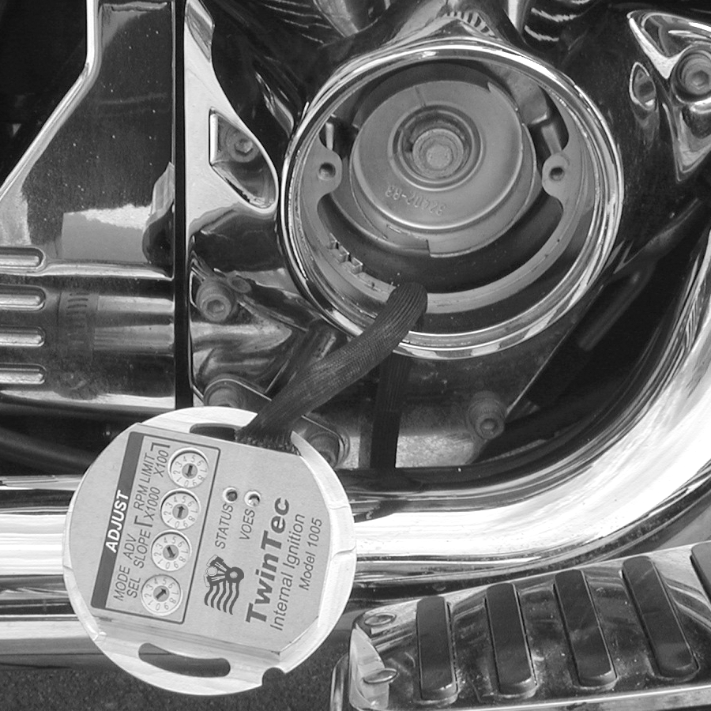

- You can completely remove the Gill ignition module and associated wiring, except for the White/Black switched +12 volt wire at the coils and the White/Violet tach wire.
- Install the Model 1005-IH unit. Wrap one turn of electrical tape around the end of the protective wire harness sleeve. This will compress the sleeve and allow you to easily feed it through the cable exit hole in the gear case cover. The tape will also keep the sleeve end from fraying. It may be helpful to enlarge the exit hole with a drill.
- Rotate the unit and then place it into position as shown in Figure 2. Be careful to avoid damage to the black plastic Hall effect sensors on the bottom of the unit.
- Route the wiring harness along the side of the unit and install the mounting standoffs as shown in Figure 3. Do not fully tighten the standoffs or install the outer cover plate until after the static timing procedure.
Figure 2 - Installing Unit (Note Orientation)
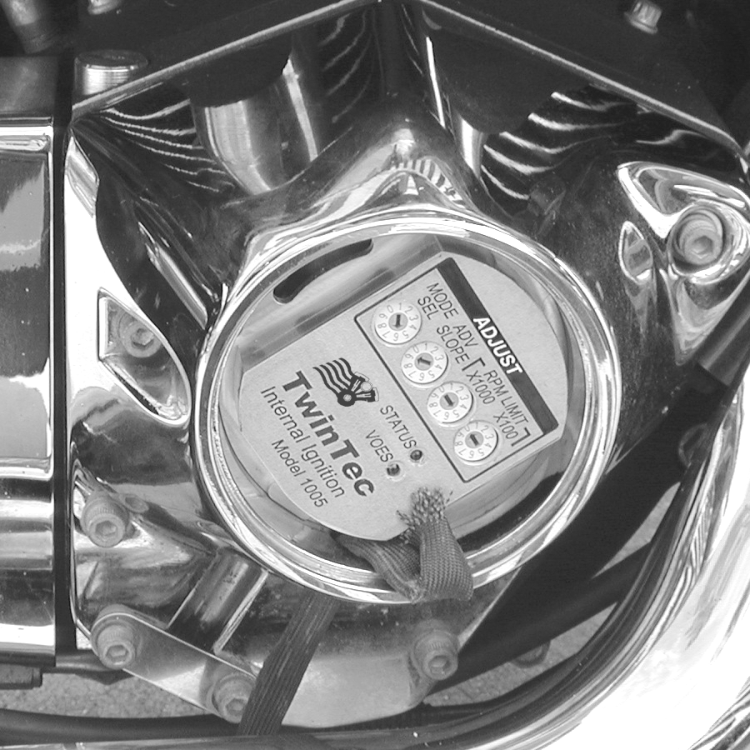
Figure 3 - Finished Installation
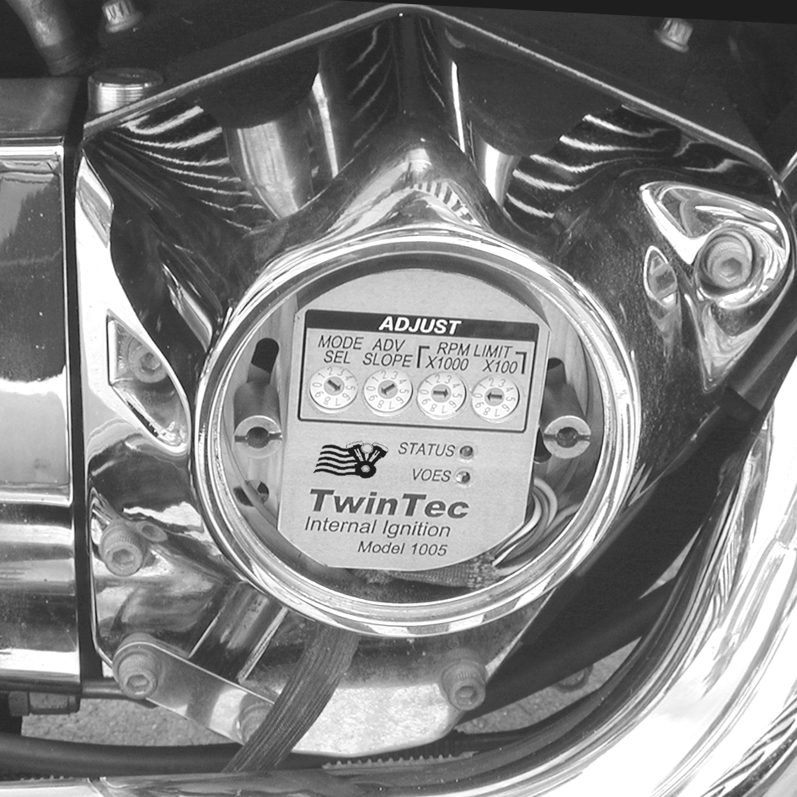

- Install the new Twin Tec mini-coils and VOES switch. Route the wire harness along the frame tubing to the ignition coils. Make sure that the harness is clear of hot exhaust areas and cannot chafe against sharp edges. Secure the harness with nylon cable ties.
- Refer to the Figure 4. Use appropriate crimp terminals for coil and VOES hookup. Tape up any unused wires.
- Install the supplied Weather Pack connector set on the brown tachometer wire as shown. Use a proper Weather Pack crimping tool or solder the terminals. Pioneer-Standard (www.packard.pios.com) sells Packard crimping tool P/N 12014254. Snap-on sells a low cost tool, P/N PWC30.
- Reconnect the battery ground cable. Complete the setup and timing procedures given on pages 4-6.
- Reinstall the cover plate using two supplied 10-24 x 1/4" socket head screws and lock washers in place of the original rivets. You will have to tap the rivet holes on the inner plate (do this with the plate removed from the bike to avoid damaging the ignition). You can use the supplied 10-24 x 3/8" self threading screw as a tap.
NOTE: The unit is grounded by means of the gear case housing. The mounting surface must not be anodized or painted.

CAUTION: Engine damage from excessive timing advance may result if the purple/white VOES wire is inadvertently shorted to ground.
Figure 4 – American IronHorse® Single Fire Wiring Diagram
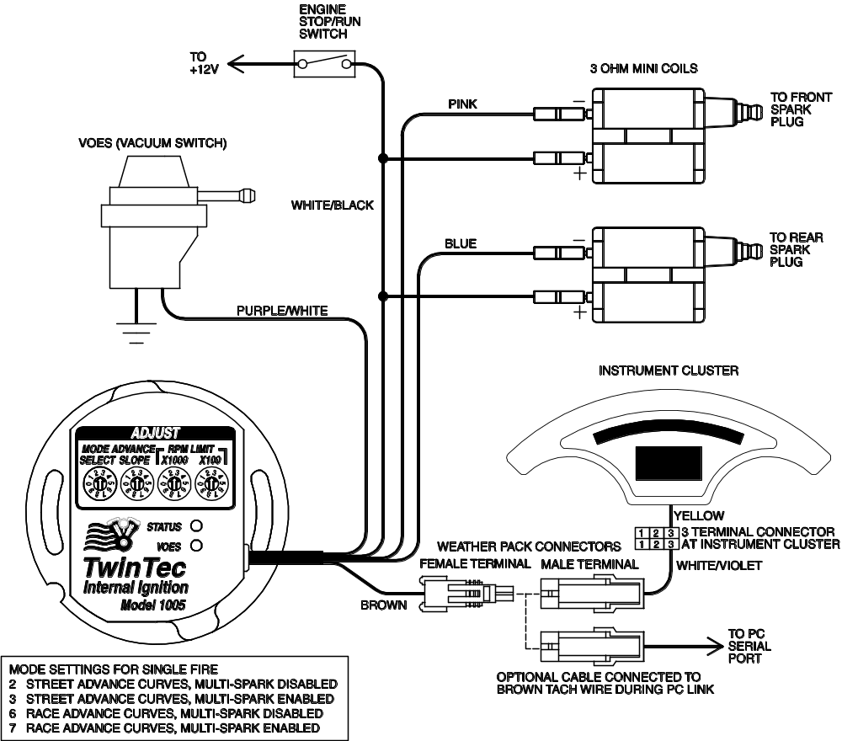

OPERATING MODES
A single 10 position rotary switch is used to select the operating mode. Switch settings are as follows:
0 Street advance curves, dual fire, multi-spark disabled
1 Street advance curves, dual fire, multi-spark enabled
2 Street advance curves, single fire, multi-spark disabled
3 Street advance curves, single fire, multi-spark enabled
4 Race advance curves, dual fire, multi-spark disabled
5 Race advance curves, dual fire, multi-spark enabled
6 Race advance curves, single fire, multi-spark disabled
7 Race advance curves, single fire, multi-spark enabled
8-9 Boot load mode (see text)
The engine will not run if the mode switch setting does not match the wiring hookup. For the American IronHorse® hookup, you should use mode 6 or 7.
Advance curve families are shown in Figures 5 and 6. Use the street advance curves (mode switch settings 0-3) for stock or mildly modified engines. Use the race advance curves (mode switch settings 4-7) for high compression engines.
We recommend that you enable multi-spark. When multi-spark is enabled, a continuous series of sparks is fired from the advanced timing point until TDC. Most air-cooled engines require relatively cold spark plugs to prevent detonation under high load. Multi-spark reduces the consequent tendency for plug fouling at idle.
TUNING TIP: Lean air/fuel ratio (AFR) increases the tendency for spark knock. Check AFR and rejet carburetor before optimizing ignition timing. Test the motorcycle on a dyno with an exhaust gas sniffer or use our WEGO.
Switch settings 8-9 are used only for a special "boot load" mode that allows loading an entirely new program into the processor FLASH memory. This would only be done in special circumstances.

RECOMMENDED TIMING SETTINGS
Street and race advance curve families are shown in Figures 5 and 6. Each family has minimum and maximum curves. The advance slope switch allows you to run an advance curve in between these minimum and maximum curves. Advance slope switch setting zero corresponds to the minimum advance curve. Switch setting 9 corresponds to the maximum advance curve. Higher switch settings result in a more aggressive curve.
Tuning a particular engine setup always requires some trial and error experimentation, but maximum power is usually obtained by using the highest advance setting possible without audible spark knock. Some recommended starting points are given below:
For stock engines run on normal pump gas (87-89 octane), use the street advance curves and advance slope setting 5.
For stock or mildly modified engines run on 92 or higher octane gas, use the street advance curves and advance slope setting 7.
For high compression engines, use the race advance curves and advance slope setting 2.
You can adjust the initial timing by rotating the Twin Tec module relative to the gear housing (clockwise rotation increases initial timing).
If you experience spark knock only at low RPM, you can try reducing the initial timing while maintaining an aggressive advance slope for maximum power at high RPM by increasing the advance slope switch setting. If spark knock is a problem at high RPM, decrease the advance slope switch setting.
Once you have determined the best switch settings, you can further optimize the timing at a particular RPM by programming a custom advance curve with our PC Link software and optional cable.
Note that the wide-open throttle (WOT) curves are active unless the VOES input is grounded. During idle and cruise, the VOES input is grounded (green VOES LED illuminated) and the low manifold pressure (MAP) curves are active.

RPM LIMITER SETTING
You can set the RPM limit from 3,000 to 9,900 RPM in 100 RPM increments by means of two rotary switches. The RPM limit is X100 switch setting (i.e. 57 = 5,700 RPM). Inadvertent settings below 3,000 RPM are ignored and result in a 3,000 RPM limit.
The Model 1005 uses a newly developed RPM limiting algorithm that has been highly optimized for odd firing V twin engines. When the engine is held against the RPM limit, cylinder firing is always paired. This eliminates a torque couple and results in very smooth operation compared to random or sequence type RPM limiters.
Set a safe RPM limit that is appropriate for your engine. Most engines with OE valvetrain components should not be run over 5,700 RPM.

STATIC TIMING PROCEDURE
- Timing marks are located on the flywheel and may be viewed by unscrewing the inspection hole plug. Most engines will have both TDC and advance timing marks for the front cylinder as shown in Figure 7. If you are not sure, refer to your shop manual. You can also identify the TDC mark by removing the spark plugs and rotating the crankshaft (turn rear wheel in high gear) until the front piston comes up on TDC.
- For static timing, you must rotate the crankshaft so that the front piston is at TDC on the compression stroke. Remove spark plugs and rotate crankshaft. If you place your thumb over the spark plug hole, you will feel pressure as the piston comes up on the compression stroke. Continue rotating the crankshaft until the TDC mark is precisely centered in the inspection hole.
- Ground the spark plug cables to avoid a shock hazard. You can use small jumper wires with alligator clips for this purpose.
- Turn on the ignition switch. The red LED is used as a timing indicator. Note that the LED does not immediately illuminate when power is first turned on. Rotate the ignition unit back and forth until the red LED illuminates. Then slowly rotate the unit clockwise until the LED goes out. Note that the LED goes out at TDC.
- Tighten the standoffs to secure the unit. Turn off the ignition switch and reinstall the spark plugs.

PRECISE TIMING PROCEDURE
- Use a standard timing light. Note that most dial-back type timing lights will not work correctly with dual fire applications. If you have a dial-back timing light, set the dial-back to zero. Do not enable multi-spark while setting timing.
- The precise timing procedure is based on using the 35° BTDC timing mark and race maximum advance curve with VOES grounded that reaches 35° BTDC around 2,000 RPM (refer to Figure 6). To use this procedure, you must have a VOES switch connected. If a VOES switch is not used, you must ground the purple/white wire while setting the timing.
- Set mode switch to 6 for single fire. Set advance slope switch to 9. Connect the timing light pickup to the front cylinder spark plug cable. Loosen standoffs securing the ignition unit. Run the engine at a steady speed just over 2,000 RPM. Rotate the ignition to center the 35° BTDC timing mark in the inspection hole. Tighten standoffs and verify that the timing has not changed. When done, change mode and advance slope switches back to desired values.

GENERAL RECOMMENDATIONS
Coil primary resistance must not be less than 3 ohms. Most OE style aftermarket single fire coils meet this requirement. Coils for the new Twin Cam 88® engine have low primary resistance and are not compatible.
Due to the short lengths involved on motorcycle applications, energy losses in spark plug wires are insignificant. OE carbon core suppression cables will deteriorate after several years. For a more durable replacement, we suggest spiral core spark plug cables.
The red status LED is internally connected to the tachometer output. If the red status LED blinks, the tachometer output should be functional.

VOES CONSIDERATIONS
CAUTION: Do not use solid copper spark plug cables or non-resistor type spark plugs. The unit may misfire.
The vacuum switch (VOES) provides the vacuum advance required by all street driven engines. Additional advance under low manifold pressure conditions improves idle stability and fuel economy. Without vacuum advance at idle and part throttle, thermodynamic efficiency is reduced and engine temperatures increase significantly.
The VOES is normally open. At low manifold pressure (or manifold vacuum greater than 6-7 inch-Hg), the VOES grounds the purple/white wire and causes the Twin Tec module to generate additional timing advance. The green VOES LED illuminates whenever the VOES input is active (timing advanced).
The use of a VOES is required for proper operation of the Model 1005-IH module. The kit includes a VOES switch with a vacuum switching level of 6-7 inch-Hg that helps eliminate spark knock under light load or throttle roll-on.

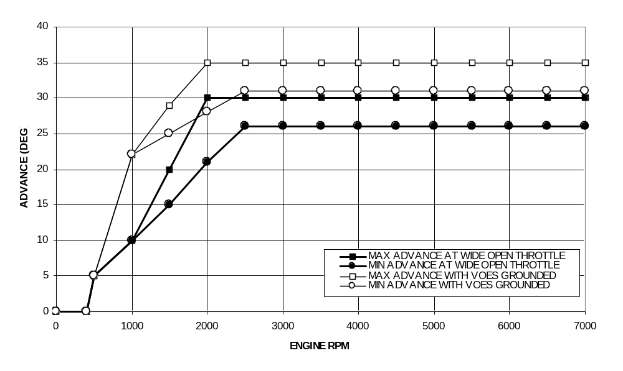Figure 5 - Street Advance Curves
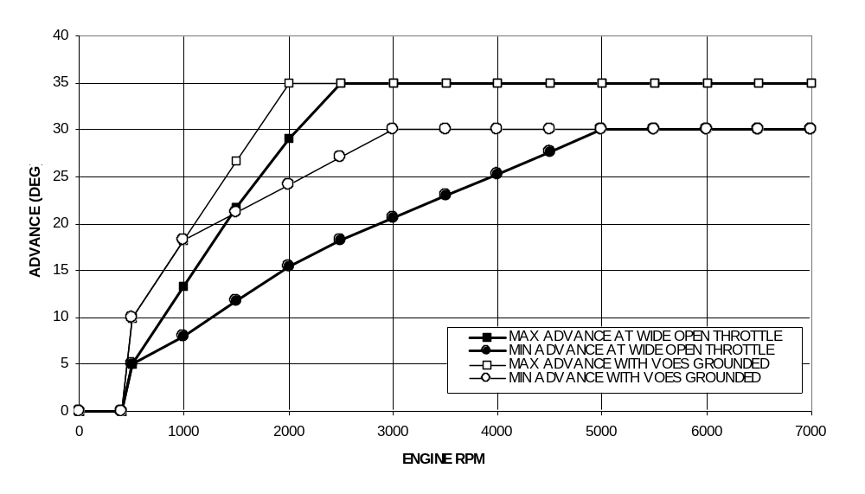Figure 6 - Race Advance Curves
Figure 7 - Front Cylinder Timing Marks
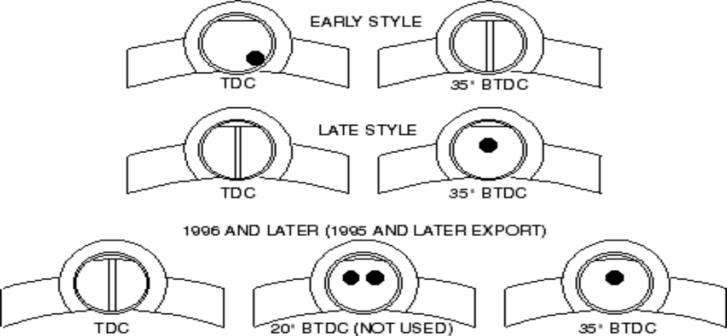

PC LINK CABLE AND SOFTWARE
The new Twin Tec USB Interface (P/N 18014) provides PC connectivity for all of our engine controls (ignition and fuel injection systems) and eliminates the requirement for multiple cables or a separate USB adapter. Two Windows based programs are available for use with the Model 1005-IH: PC Link Evo for programming custom advance curves and other engine parameters and Operating Statistics for viewing engine operating data. The latest versions of our software are always available for download on our website. The software is free and will work in demo mode without a Twin Tec module attached. Refer to the software documentation for details.
The brown tachometer wire is used for the PC link. The PC link can access the Twin Tec module when the ignition is turned on and the engine has not yet been started. Once the engine is started, the brown wire resumes its normal function of driving the tachometer. Note that no damage occurs if the engine is inadvertently started while the PC link is still attached.
TROUBLESHOOTING TIP: If you are installing an internal (nose cone) ignition for the first time and the engine will not start, the most likely problem is improper static timing. Make sure that the front piston is at TDC on the compression stroke and not on the exhaust stroke.
The optional USB interface cable connects to the brown tachometer wire as shown in Figure 4. The cable also has a ground clip that must be connected to frame or engine ground. The other end of the cable connects to the USB port on a laptop PC.

USE OF VOES INPUT FOR RETARD
The Model 1005-IH can be programmed to allow alternate usage of the purple/white VOES wire as a retard input. If this feature is enabled, the unit will retard timing up to 10 degrees when the purple/white wire is grounded. This retard feature is useful for turbocharger or nitrous oxide injection applications. Twin Tec PC Link Evo software and USB interface cable (P/N 18014) are required to program the retard feature.

TROUBLESHOOTING FLOWCHART
Follow the troubleshooting flowchart shown on the next page. Experience has shown that most units returned for warranty are OK and another problem, such as a defective coil, is later identified.

Troubleshooting Flowchart


